**UNIT_IV**

|  |
| --- |
| **Overview**  Load flow studies are one of the most important aspects of power system planning and operation. The load flow gives us the sinusoidal steady state of the entire system - voltages, real and reactive power generated and absorbed and line losses. Since the load is a static quantity and it is the power that flows through transmission lines, the purists prefer to call this **Power Flow studies** rather than load flow studies. We shall however stick to the original nomenclature of load flow.  Through the load flow studies we can obtain the voltage magnitudes and angles at each bus in the steady state. This is rather important as the magnitudes of the bus voltages are required to be held within a specified limit. Once the bus voltage magnitudes and their angles are computed using the load flow, the real and reactive power flow through each line can be computed. Also based on the difference between power flow in the sending and receiving ends, the losses in a particular line can also be computed. Furthermore, from the line flow we can also determine the over and under load conditions.  The steady state power and reactive power supplied by a bus in a power network are expressed in terms of nonlinear algebraic equations. We therefore would require iterative methods for solving these equations. In this chapter we shall discuss two of the load flow methods. We shall also delineate how to interpret the load flow results. |

|  |  |  |  |  |  |  |  |  |  |  |  |  |  |  |  |  |
| --- | --- | --- | --- | --- | --- | --- | --- | --- | --- | --- | --- | --- | --- | --- | --- | --- |
| **Section I:  Real And Reactive Power Injected in a Bus**  For the formulation of the real and reactive power entering a b us, we need to define the following quantities. Let the voltage at the *ith*bus be denoted by   |  |  | | --- | --- | | http://nptel.ac.in/courses/Webcourse-contents/IIT-KANPUR/power-system/chapter_4/images/image002.gif | (4.1) |     Also let us define the self admittance at bus- *i*as   |  |  | | --- | --- | | http://nptel.ac.in/courses/Webcourse-contents/IIT-KANPUR/power-system/chapter_4/images/image004.gif | (4.2) |     Similarly the mutual admittance between the buses *i*and *j*can be written as   |  |  | | --- | --- | | http://nptel.ac.in/courses/Webcourse-contents/IIT-KANPUR/power-system/chapter_4/images/image006.gif | (4.3) |     Let the power system contains a total number of *n*buses. The current injected at bus- *i*is given as   |  |  | | --- | --- | | http://nptel.ac.in/courses/Webcourse-contents/IIT-KANPUR/power-system/chapter_4/images/image008.gif | (4.4) |       It is to be noted we shall assume the current entering a bus to be positive and that leaving the bus to be negative. As a consequence the power and reactive power entering a bus will also be assumed to be positive. The complex power at bus- *i*is then given by   |  |  | | --- | --- | | http://nptel.ac.in/courses/Webcourse-contents/IIT-KANPUR/power-system/chapter_4/images/image010.gif | (4.5) |           Note that   |  |  | | --- | --- | | http://nptel.ac.in/courses/Webcourse-contents/IIT-KANPUR/power-system/chapter_4/images/image012.gif |  |         Therefore substituting in (4.5) we get the real and reactive power as   |  |  | | --- | --- | | http://nptel.ac.in/courses/Webcourse-contents/IIT-KANPUR/power-system/chapter_4/images/image014.gif | (4.6) | | http://nptel.ac.in/courses/Webcourse-contents/IIT-KANPUR/power-system/chapter_4/images/image016.gif | (4.7) | |

# **Section II:  Classification Of Buses**

For load flow studies it is assumed that the loads are constant and they are defined by their real and reactive power consumption. It is further assumed that the generator terminal voltages are tightly regulated and therefore are constant. The main objective of the load flow is to find the voltage magnitude of each bus and its angle when the powers generated and loads are pre-specified. To facilitate this we classify the different buses of the power system shown in the chart below.

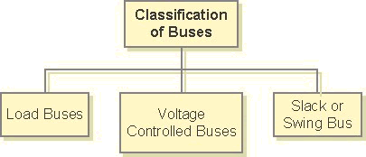

In the next slide we'll discuss them in details.

# **Classification Of Buses**

**Load Buses**: In these buses no generators are connected and hence the generated real power PGiand reactive power QGi are taken as zero. The load drawn by these buses are defined by real power -PLi and reactive power -QLi in which the negative sign accommodates for the power flowing out of the bus. This is why these buses are sometimes referred to as P-Q bus. The objective of the load flow is to find the bus voltage magnitude |Vi| and its angle δi.

**Voltage Controlled Buses**: These are the buses where generators are connected. Therefore the power generation in such buses is controlled through a prime mover while the terminal voltage is controlled through the generator excitation. Keeping the input power constant through turbine-governor control and keeping the bus voltage constant using automatic voltage regulator, we can specify constant PGi and | Vi|for these buses. This is why such buses are also referred to as P-V buses. It is to be noted that the reactive power supplied by the generator QGi depends on the system configuration and cannot be specified in advance. Furthermore we have to find the unknown angle δi of the bus voltage.

**Slack or Swing Bus**: Usually this bus is numbered 1 for the load flow studies. This bus sets the angular reference for all the other buses. Since it is the angle difference between two voltage sources that dictates the real and reactive power flow between them, the particular angle of the slack bus is not important. However it sets the reference against which angles of all the other bus voltages are measured. For this reason the angle of this bus is usually chosen as 0° . Furthermore it is assumed that the magnitude of the voltage of this bus is known.

Now consider a typical load flow problem in which all the load demands are known. Even if the generation matches the sum total of these demands exactly, the mismatch between generation and load will persist because of the line *I 2*Rlosses. Since the *I 2*R loss of a line depends on the line current which, in turn, depends on the magnitudes and angles of voltages of the two buses connected to the line, it is rather difficult to estimate the loss without calculating the voltages and angles. For this reason a generator bus is usually chosen as the slack bus without specifying its real power. It is assumed that the generator connected to this bus will supply the balance of the real power required and the line losses.

|  |  |  |  |  |  |  |  |  |  |  |  |  |  |  |  |  |  |  |  |  |  |  |  |  |  |  |  |  |  |  |  |  |  |  |  |  |  |  |  |  |  |  |  |  |  |  |  |  |  |  |  |  |  |  |  |  |  |  |  |  |  |  |  |  |  |  |  |  |  |  |  |  |  |  |  |  |  |  |  |  |  |  |  |  |  |  |  |  |  |  |  |  |  |  |  |  |  |  |  |  |  |  |  |  |  |  |  |  |  |  |  |  |  |  |  |
| --- | --- | --- | --- | --- | --- | --- | --- | --- | --- | --- | --- | --- | --- | --- | --- | --- | --- | --- | --- | --- | --- | --- | --- | --- | --- | --- | --- | --- | --- | --- | --- | --- | --- | --- | --- | --- | --- | --- | --- | --- | --- | --- | --- | --- | --- | --- | --- | --- | --- | --- | --- | --- | --- | --- | --- | --- | --- | --- | --- | --- | --- | --- | --- | --- | --- | --- | --- | --- | --- | --- | --- | --- | --- | --- | --- | --- | --- | --- | --- | --- | --- | --- | --- | --- | --- | --- | --- | --- | --- | --- | --- | --- | --- | --- | --- | --- | --- | --- | --- | --- | --- | --- | --- | --- | --- | --- | --- | --- | --- | --- | --- | --- | --- | --- | --- |
| **Section III:   Preparation Of Data For Load Flow**  Let real and reactive power generated at bus- *i*be denoted by *PGi*and *QGi* respectively. Also let us denote the real and reactive power consumed at the *i th*th bus by *PLi*and *QLi*respectively. Then the net real power injected in bus- *i*is   |  |  | | --- | --- | | http://nptel.ac.in/courses/Webcourse-contents/IIT-KANPUR/power-system/chapter_4/images/image018.gif | (4.8) |     Let the injected power calculated by the load flow program be *Pi, calc*. Then the mismatch between the actual injected and calculated values is given by   |  |  | | --- | --- | | http://nptel.ac.in/courses/Webcourse-contents/IIT-KANPUR/power-system/chapter_4/images/image020.gif | (4.9) |     In a similar way the mismatch between the reactive power injected and calculated values is given by   |  |  | | --- | --- | | http://nptel.ac.in/courses/Webcourse-contents/IIT-KANPUR/power-system/chapter_4/images/image022.gif | (4.10) |     The purpose of the load flow is to minimize the above two mismatches. It is to be noted that (4.6) and (4.7) are used for the calculation of real and reactive power in (4.9) and (4.10). However since the magnitudes of all the voltages and their angles are not known a priori, an iterative procedure must be used to estimate the bus voltages and their angles in order to calculate the mismatches. It is expected that mismatches Δ*Pi*and Δ*Qi* reduce with each iteration and the load flow is said to have converged when the mismatches of all the buses become less than a very small number.  For the load flow studies we shall consider the system of Fig. 4.1, which has 2 generator and 3 load buses. We define bus-1 as the slack bus while taking bus-5 as the P-V bus. Buses 2, 3 and 4 are P-Q buses. The line impedances and the line charging admittances are given in Table 4.1. Based on this data the *Y bus*matrix is given in Table 4.2. This matrix is formed using the same procedure as given in Section 3.1.3. It is to be noted here that the sources and their internal impedances are not considered while forming the *Ybus*matrix for load flow studies which deal only with the bus voltages.  http://nptel.ac.in/courses/Webcourse-contents/IIT-KANPUR/power-system/chapter_4/images/image024.jpg  **Fig. 4.1 The simple power system used for load flow studies.**    **Table 4.1 Line impedance and line charging data of the system of Fig. 4.1.**   |  |  |  | | --- | --- | --- | | **Line (bus to bus)** | **Impedance** | **Line charging ( *Y*/2)** | | 1-2 | 0.02 + *j*0.10 | *j*0.030 | | 1-5 | 0.05 + *j*0.25 | *j*0.020 | | 2-3 | 0.04 + *j*0.20 | *j*0.025 | | 2-5 | 0.05 + *j*0.25 | *j*0.020 | | 3-4 | 0.05 + *j*0.25 | *j*0.020 | | 3-5 | 0.08 + *j*0.40 | *j*0.010 | | 4-5 | 0.10 + *j*0.50 | *j*0.075 |     **Table 4.2 *Ybus*matrix of the system of Fig. 4.1.**   |  |  |  |  |  |  | | --- | --- | --- | --- | --- | --- | |  | **1** | **2** | **3** | **4** | **5** | | **1** | 2.6923 - *j*13.4115 | - 1.9231 + *j*9.6154 | 0 | 0 | - 0.7692 + *j*3.8462 | | **2** | - 1.9231 + *j*9.6154 | 3.6538 - *j*18.1942 | - 0.9615 + *j*4.8077 | 0 | - 0.7692 + *j*3.8462 | | **3** | 0 | - 0.9615 + *j*4.8077 | 2.2115 - *j*11.0027 | - 0.7692 + *j*3.8462 | - 0.4808 + *j*2.4038 | | **4** | 0 | 0 | - 0.7692 + *j*3.8462 | 1.1538 - *j*5.6742 | - 0.3846 + *j*1.9231 | | **5** | - 0.7692 + *j*3.8462 | - 0.7692 + *j*3.8462 | - 0.4808 + *j*2.4038 | - 0.3846 + *j*1.9231 | 2.4038 - *j*11.8942 |   The bus voltage magnitudes, their angles, the power generated and consumed at each bus are given in Table 4.3. In this table some of the voltages and their angles are given in boldface letters. This indicates that these are initial data used for starting the load flow program. The power and reactive power generated at the slack bus and the reactive power generated at the P-V bus are unknown. Therefore each of these quantities are indicated by a dash ( - ). Since we do not need these quantities for our load flow calculations, their initial estimates are not required. Also note from Fig. 4.1 that the slack bus does not contain any load while the P-V bus 5 has a local load and this is indicated in the load column.    **Table 4.3 Bus voltages, power generated and load - initial data.**   |  |  |  |  |  |  |  | | --- | --- | --- | --- | --- | --- | --- | | Bus no. | Bus voltage | | Power generated | | Load | | |  | Magnitude (pu) | Angle (deg) | P (MW**)** | Q (MVAr) | P (MW) | P (MVAr) | | 1 | 1.05 | 0 | - | - | 0 | 0 | | 2 | **1** | **0** | 0 | 0 | 96 | 62 | | 3 | **1** | **0** | 0 | 0 | 35 | 14 | | 4 | **1** | **0** | 0 | 0 | 16 | 8 | | 5 | 1.02 | **0** | 48 | - | 24 | 11 | |

**Section IV:   Load Flow by Gauss-Seidel Method**

* [**Updating Load Bus Voltages**](http://nptel.ac.in/courses/Webcourse-contents/IIT-KANPUR/power-system/chapter_4/4_6.html)
* [**Updating P-V Bus Voltages**](http://nptel.ac.in/courses/Webcourse-contents/IIT-KANPUR/power-system/chapter_4/4_7.html)
* [**Convergence of the Algorithm**](http://nptel.ac.in/courses/Webcourse-contents/IIT-KANPUR/power-system/chapter_4/4_8.html)

The basic power flow equations (4.6) and (4.7) are nonlinear. In an *n*-bus power system, let the number of P-Q buses be *np*and the number of P-V (generator) buses be *ng* such that *n*= *np* + *ng* + 1. Both voltage magnitudes and angles of the P-Q buses and voltage angles of the P-V buses are unknown making a total number of 2*np* + *ng* quantities to be determined. Amongst the known quantities are 2*np* numbers of real and reactive powers of the P-Q buses, 2*ng* numbers of real powers and voltage magnitudes of the P-V buses and voltage magnitude and angle of the slack bus. Therefore there are sufficient numbers of known quantities to obtain a solution of the load flow problem. However, it is rather difficult to obtain a set of closed form equations from (4.6) and (4.7). We therefore have to resort to obtain iterative solutions of the load flow problem.

At the beginning of an iterative method, a set of values for the unknown quantities are chosen. These are then updated at each iteration. The process continues till errors between all the known and actual quantities reduce below a pre-specified value. In the Gauss-Seidel load flow we denote the initial voltage of the *ith*bus by *Vi(0)*, *i*= 2, ... , *n*. This should read as the voltage of the *ith*bus at the 0th iteration, or initial guess. Similarly this voltage after the first iteration will be denoted by *Vi(1)* . In this Gauss-Seidel load flow the load buses and voltage controlled buses are treated differently. However in both these type of buses we use the complex power equation given in (4.5) for updating the voltages. Knowing the real and reactive power injected at any bus we can expand (4.5) as

|  |  |
| --- | --- |
| http://nptel.ac.in/courses/Webcourse-contents/IIT-KANPUR/power-system/chapter_4/images/image026.gif | (4.11) |

We can rewrite (4.11) as

|  |  |
| --- | --- |
| http://nptel.ac.in/courses/Webcourse-contents/IIT-KANPUR/power-system/chapter_4/images/image028.gif | (4.12) |

In this fashion the voltages of all the buses are updated. We shall outline this procedure with the help of the system of Fig. 4.1, with the system data given in Tables 4.1 to 4.3. It is to be noted that the real and reactive powers are given respectively in MW and MVAr. However they are converted into per unit quantities where a base of 100 MVA is chosen.

**Updating Load Bus Voltages**

Let us start the procedure with bus-2 of the 5 bus 7 line system given in fig: 4.1. Since this is load bus, both the real and reactive power into this bus is known. We can therefore write from (4.12)

|  |  |
| --- | --- |
| http://nptel.ac.in/courses/Webcourse-contents/IIT-KANPUR/power-system/chapter_4/images/image030.gif | (4.13) |

From the data given in Table 4.3 we can write

|  |  |
| --- | --- |
| http://nptel.ac.in/courses/Webcourse-contents/IIT-KANPUR/power-system/chapter_4/images/image032.gif |  |

It is to be noted that since the real and reactive power is drawn from this bus, both these quantities appear in the above equation with a negative sign. With the values of the *Y bus*elements given in Table 4.2 we get *V21*= 0.9927 < − 2.5959° .

The first iteration voltage of bus-3 is given by

|  |  |
| --- | --- |
| http://nptel.ac.in/courses/Webcourse-contents/IIT-KANPUR/power-system/chapter_4/images/image034.gif | (4.14) |

Note that in the above equation since the update for the bus-2 voltage is already available, we used the 1st iteration value of this rather than the initial value. Substituting the numerical data we get *V3(1)*= 0.9883 < − 2. 8258° . Finally the bus-4 voltage is given by

|  |  |
| --- | --- |
| http://nptel.ac.in/courses/Webcourse-contents/IIT-KANPUR/power-system/chapter_4/images/image036.gif | (4.15) |

Solving we get *V4(1)*= 0. 9968 < −3.4849° .

|  |  |  |  |  |  |  |  |  |  |  |
| --- | --- | --- | --- | --- | --- | --- | --- | --- | --- | --- |
| **Updating P-V Bus Voltages**  It can be seen from Table 4.3 that even though the real power is specified for the P-V bus-5, its reactive power is unknown. Therefore to update the voltage of this bus, we must first estimate the reactive power of this bus. Note from Fig. 4.11 that   |  |  | | --- | --- | | http://nptel.ac.in/courses/Webcourse-contents/IIT-KANPUR/power-system/chapter_4/images/image038.gif | (4.16) |       And hence we can write the *kth*iteration values as   |  |  | | --- | --- | | http://nptel.ac.in/courses/Webcourse-contents/IIT-KANPUR/power-system/chapter_4/images/image040.gif | (4.17) |       For the system of Fig. 4.1 we have   |  |  | | --- | --- | | http://nptel.ac.in/courses/Webcourse-contents/IIT-KANPUR/power-system/chapter_4/images/image042.gif | (4.18) |       This is computed as 0.0899 per unit. Once the reactive power is estimated, the bus-5 voltage is updated as   |  |  | | --- | --- | | http://nptel.ac.in/courses/Webcourse-contents/IIT-KANPUR/power-system/chapter_4/images/image044.gif | (4.19) |       It is to be noted that even though the power generation in bus-5 is 48 MW, there is a local load that is consuming half that amount. Therefore the net power injected by this bus is 24 MW and consequently the injected power *P5, inj*in this case is taken as 0.24 per unit. The voltage is calculated as *V5(1)*= 1.0169 < − 0.8894° . Unfortunately however the magnitude of the voltage obtained above is not equal to the magnitude given in Table 4.3. We must therefore force this voltage magnitude to be equal to that specified. This is accomplished by   |  |  | | --- | --- | | http://nptel.ac.in/courses/Webcourse-contents/IIT-KANPUR/power-system/chapter_4/images/image046.gif | (4.20) |       This will fix the voltage magnitude to be 1.02 per unit while retaining the phase of − 0.8894 ° . The corrected voltage is used in the next iteration. |

**Convergence of the Algorithm**

As can be seen from Table 4.3 that a total number of 4 real and 3 reactive powers are known to us. We must then calculate each of these from (4.6) and (4.7) using the values of the voltage magnitudes and their angle obtained after each iteration. The power mismatches are then calculated from (4.9) and (4.10). The process is assumed to have converged when each of Δ*P2* , Δ*P3*, Δ*P4* , Δ*P5* , Δ*Q2* , Δ*Q3* and Δ*Q4* is below a small pre-specified value. At this point the process is terminated.

Sometimes to accelerate computation in the P-Q buses the voltages obtained from (4.12) is multiplied by a constant. The voltage update of bus- *i*is then given by

|  |  |
| --- | --- |
| http://nptel.ac.in/courses/Webcourse-contents/IIT-KANPUR/power-system/chapter_4/images/image048.gif | (4.21) |

where *λ*is a constant that is known as the **acceleration factor**. The value of *λ*has to be below 2.0 for the convergence to occur. Table 4.4 lists the values of the bus voltages after the 1st iteration and number of iterations required for the algorithm to converge for different values of λ. It can be seen that the algorithm converges in the least number of iterations when *λ*is 1.4 and the maximum number of iterations are required when λ is 2. In fact the algorithm will start to diverge if larger values of acceleration factor are chosen

[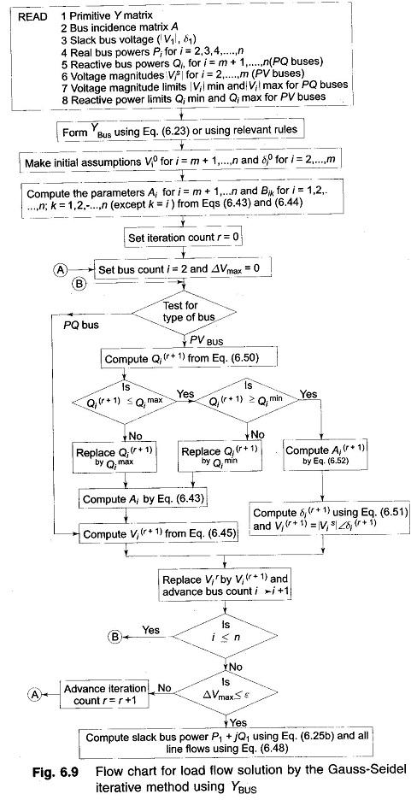](http://www.eeeguide.com/wp-content/uploads/2016/11/Gauss-Seidel-Method-19.jpg)

[**Newton Raphson Method**](http://www.eeeguide.com/newton-raphson-method/)**:**

The [Newton Raphson Method](http://www.eeeguide.com/newton-raphson-method/) is a powerful method of solving non-linear algebraic equations. It works faster and is sure to converge in most cases as compared to the GS method. It is indeed the practical method of load flow solution of large power networks. Its only drawback is the large requirement of computer memory which has been overcome through a compact storage scheme (see Appendix C). Convergence can be considerably speeded up by performing the first iteration through the GS method and using the values so obtained for starting the NR iterations. Before explaining how the NR method is applied to solve the [load flow problem](http://www.eeeguide.com/load-flow-problem/), it is useful to review the method in its general form.

Consider a set of n non-linear algebraic equations

[Newton Raphson Method](http://www.eeeguide.com/wp-content/uploads/2016/11/Newton-Raphson-Method.jpg)

Assume initial values of unknowns as

[Newton Raphson Method](http://www.eeeguide.com/wp-content/uploads/2016/11/Newton-Raphson-Method-1.jpg)

be the corrections, which on being added to the initial guess, give the actual solution. Therefore

[Newton Raphson Method](http://www.eeeguide.com/wp-content/uploads/2016/11/Newton-Raphson-Method-2.jpg)

Expanding these equations in Taylor series around the initial guess, we have

[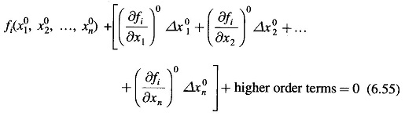](http://www.eeeguide.com/wp-content/uploads/2016/11/Newton-Raphson-Method-3.jpg)

[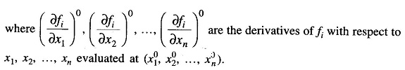](http://www.eeeguide.com/wp-content/uploads/2016/11/Newton-Raphson-Method-4.jpg)

Neglecting higher order terms we can write Eq. (6.55) in matrix form

[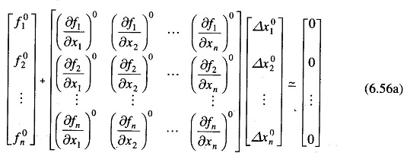](http://www.eeeguide.com/wp-content/uploads/2016/11/Newton-Raphson-Method-5.jpg)

or in vector matrix form

[Newton Raphson Method](http://www.eeeguide.com/wp-content/uploads/2016/11/Newton-Raphson-Method-6.jpg)

J° is known as the Jacobian matrix (obtained by differentiating the function vector f with respect to x and evaluating it at x°). Equation (6.56b) can be written as

[Newton Raphson Method](http://www.eeeguide.com/wp-content/uploads/2016/11/Newton-Raphson-Method-7.jpg)

Approximate values of corrections Δx° can be obtained from Eq (6.57). These being a set of linear algebraic equations can be solved efficiently by triangularization and back substitution (see Appendix C).

Updated values of x are then

[Newton Raphson Method](http://www.eeeguide.com/wp-content/uploads/2016/11/Newton-Raphson-Method-8.jpg)

or, in general, for the (r + 1)th iteration

[Newton Raphson Method](http://www.eeeguide.com/wp-content/uploads/2016/11/Newton-Raphson-Method-9.jpg)

Iterations are continued till Eq. (6.53) is satisfied to any desired accuracy, i.e.

### [Newton Raphson Method](http://www.eeeguide.com/wp-content/uploads/2016/11/Newton-Raphson-Method-10.jpg)**NR Algorithm for Load flow Solution**

First, assume that all buses are PQ buses. At any PQ bus the load flow solution must satisfy the following non-linear algebraic equations

[Newton Raphson Method](http://www.eeeguide.com/wp-content/uploads/2016/11/Newton-Raphson-Method-11.jpg)

where expressions for Pi and Qi are given in Eqs. (6.27) and (6.28). For a trial  set of variables |Vi|, δi, the vector of residuals f° of Eq. (6.57) corresponds to

[Newton Raphson Method](http://www.eeeguide.com/wp-content/uploads/2016/11/Newton-Raphson-Method-12.jpg)

while the vector of corrections , Δx° corresponds to

[Newton Raphson Method](http://www.eeeguide.com/wp-content/uploads/2016/11/Newton-Raphson-Method-13.jpg)

Equation (6.57) for obtaining the approximate corrections vector can be written for the load flow case as

[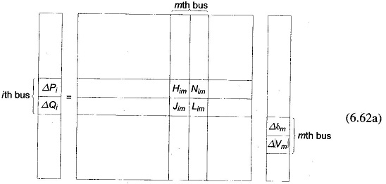](http://www.eeeguide.com/wp-content/uploads/2016/11/Newton-Raphson-Method-14.jpg)

[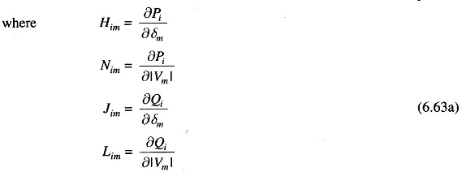](http://www.eeeguide.com/wp-content/uploads/2016/11/Newton-Raphson-Method-15.jpg)

It is to be immediately observed that the Jacobian elements corresponding to the ith bus residuals and mth bus corrections are a 2 x 2 matrix enclosed in the box in Eq. (6.62a) where i and m are both PQ buses.

Since at the slack bus (bus number 1), P1 and Q1 are unspecified and |V1|, δ1 are fixed, there are no equations corresponding to Eq. (6.60) at this bus. Hence the slack bus does not enter the Jacobian in Eq. (6.62a).

Consider now the presence of PV buses. If the ith bus is a PV bus, Qi is unspecified so that there is no equation corresponding to Eq. (6.60b) for this bus. Therefore, the Jacobian elements of the ith bus become a single row pertaining to ΔPi i.e.

[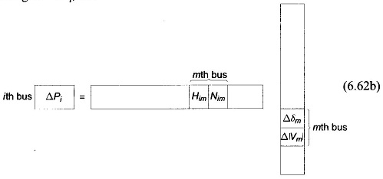](http://www.eeeguide.com/wp-content/uploads/2016/11/Newton-Raphson-Method-16.jpg)

If the mth bus is also a PV bus, |Vm| becomes fixed so that Δ|Vm| = 0. We can now write

[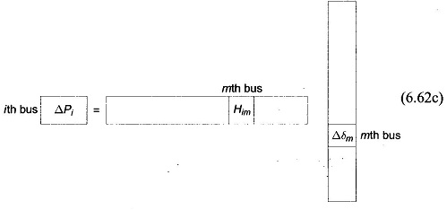](http://www.eeeguide.com/wp-content/uploads/2016/11/Newton-Raphson-Method-17.jpg)

Also if the ith bus is a PQ bus while the mth bus is a PV bus, we can then write

[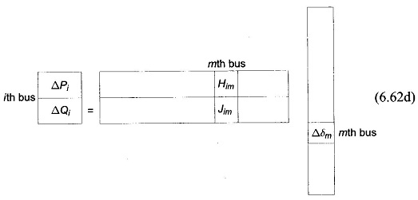](http://www.eeeguide.com/wp-content/uploads/2016/11/Newton-Raphson-Method-19.jpg)

It is convenient for numerical solution to normalize the voltage corrections

[Newton Raphson Method](http://www.eeeguide.com/wp-content/uploads/2016/11/Newton-Raphson-Method-20.jpg)

as a consequence of which, the corresponding Jacobian elements become

[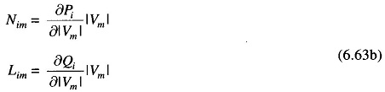](http://www.eeeguide.com/wp-content/uploads/2016/11/Newton-Raphson-Method-21.jpg)

Expressions for elements of the Jacobian (in normalized form) of the load flow Eqs. (6.60a and b) are derived in Appendix D and are given below:

[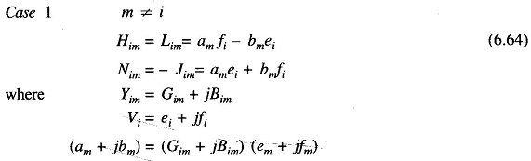](http://www.eeeguide.com/wp-content/uploads/2016/11/Newton-Raphson-Method-22.jpg)

[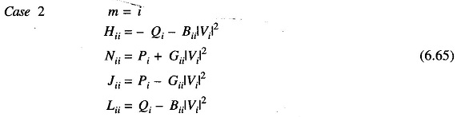](http://www.eeeguide.com/wp-content/uploads/2016/11/Newton-Raphson-Method-23.jpg)

An important observation can be made in respect of the Jacobian by examination of the YBUS matrix. If buses i and m are not connected, Yim = 0 (Gim = Bim = 0). Hence from Eqs. (6.63) and (6.64), we can write

[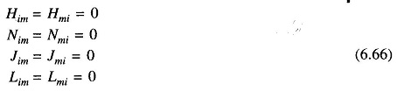](http://www.eeeguide.com/wp-content/uploads/2016/11/Newton-Raphson-Method-27.jpg)

Thus the Jacobian is as sparse as the YBUS matrix.

Formation of Eq. (6.62) of the NR method is best illustrated by a problem. Figure 6.10 shows a five-bus power network with bus types indicated therein. The matrix equation for determining the vector of corrections from the vector of residuals is given below.

Corresponding to a particular vector of variables

[Newton Raphson Method](http://www.eeeguide.com/wp-content/uploads/2016/11/Newton-Raphson-Method-25.jpg)

the vector of residuals

[Newton Raphson Method](http://www.eeeguide.com/wp-content/uploads/2016/11/Newton-Raphson-Method-26.jpg)

and the Jacobian (6 x 6 in this example) are computed. Equation (6.67) is then solved by triangularization and back substitution procedure to obtain the vector of corrections

[Newton Raphson Method](http://www.eeeguide.com/wp-content/uploads/2016/11/Newton-Raphson-Method-28.jpg)

Corrections are then added to update the vector of variables.

[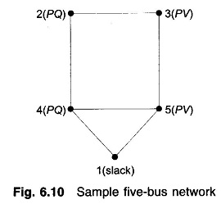](http://www.eeeguide.com/wp-content/uploads/2016/11/Newton-Raphson-Method-29.jpg)

[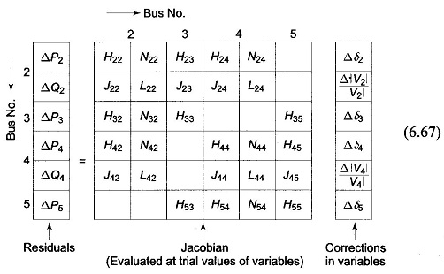](http://www.eeeguide.com/wp-content/uploads/2016/11/Newton-Raphson-Method-30.jpg)

### **Iterative Algorithm**

Omitting programming details, the iterative algorithm for the solution of the [load flow](http://www.eeeonline.org/) problem by the NR method is as follows:

1. With voltage and angle (usually δ**=**0) at slack bus fixed, assume |V|, δ at all PQ buses and δ at all PV In the absence of any other information flat voltage start is recommended.
2. Compute ΔPi (for PV and PQ buses) and ΔQi, (for all PQ buses) from (6.60a and b). If all the values are less than the prescribed tolerance, stop the iterations, calculate P1 and Q1 and print the entire solution including line flows.
3. If the convergence criterion is not satisfied, evaluate elements of the Jacobian using Eqs. (6.64) and (6.65).
4. Solve Eq. (6.67) for corrections of voltage angles and magnitudes.
5. Update voltage angles and magnitudes by adding the corresponding changes to the previous values and return to step 2.

### **Note:**

1. 1. In step 2, if there are limits on the controllable Q sources at PV buses, Q is computed each time and if it violates the limits, it is made equal to the limiting value and the corresponding PV bus is made a PQ bus in that iteration. If in the subsequent computation, Q does come within the prescribed limits, the bus is switched back to a PV bus.
2. If there are limits on the voltage of a PQ bus and if any of these limits is violated, the corresponding PQ bus is made a PV bus in that iteration with voltage fixed at the limiting value.

## [Decoupled Load Flow Methods](http://www.eeeguide.com/decoupled-load-flow-methods/)**:**

An important characteristic of any practical electric power transmission system operating in steady state is the strong interdependence between real powers and bus voltages angles and between reactive powers and voltage magnitudes. This interesting property of weak coupling between P- δ and Q-V variables gave the necessary motivation in developing the[Decoupled Load Flow Methods](http://www.eeeguide.com/decoupled-load-flow-methods/), in which P- δ and Q-V problems are solved separately.

### Decoupled Newton Methods

In any conventional Newton method, half of the elements of the Jacobean matrix represent the weak coupling referred to above, and therefore may be ignored. Any such approximation reduces the true quadratic convergence to geometric one, but there are compensating computational benefits. A large number of decoupled algorithms have been developed in the literature. However, only the most popular decoupled Newton version is presented here.  
In Eq. (6.67), the elements to be neglected are submatrices [N] and [J]. The resulting decoupled linear Newton equations become

[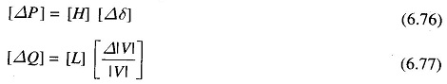](http://www.eeeguide.com/wp-content/uploads/2016/11/Decoupled-Load-Flow-Methods.jpg)where it can be shown that

[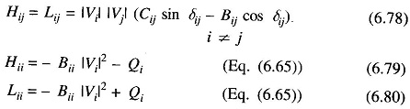](http://www.eeeguide.com/wp-content/uploads/2016/11/Decoupled-Load-Flow-Methods-1.jpg)  
Equations (6.76) and (6.77) can be constructed and solved simultaneously with each other at each iteration, updating the [H] and [L] matrices in each iteration using Eqs (6.78) to (6.80). A better approach is to conduct each iteration by first solving Eq. (6.76) for Δδ, and use the updated δ in constructing and then solving Eq. (6.77) for Δ|V|. This will result in faster convergence than in the simultaneous mode.  
The main advantage of the [Decoupled Load Flow Methods](http://www.eeeguide.com/decoupled-load-flow-methods/) (DLF) as compared to the NR method is its reduced memory requirements in storing the Jacobean. There is not much of an advantage from the point of view of speed since the time per iteration of the DLF is almost the same as that of NR method and it always takes more number of iterations to converge because of the approximation.

### Fast Decoupled Load Flow (FDLF)

Further physically justifiable simplifications may be carried out to achieve some speed advantage without much loss in accuracy of solution using the DLF model described in the previous subsection. This effort culminated in the development of the Fast Decoupled Load Flow (FDLF) method by B. Stott in 1974 [21]. The assumptions which are valid in normal power system operation are made as follows:

[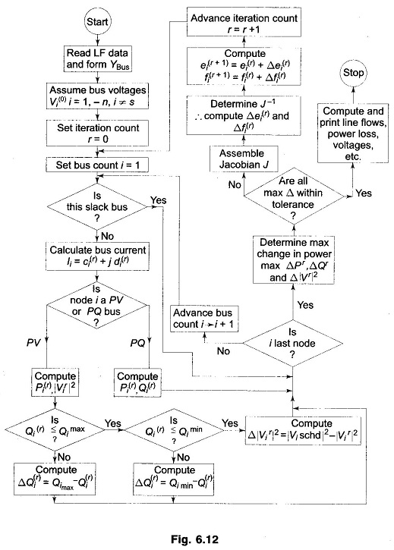](http://www.eeeguide.com/wp-content/uploads/2016/11/Decoupled-Load-Flow-Methods-2.jpg)

[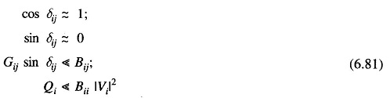](http://www.eeeguide.com/wp-content/uploads/2016/11/Decoupled-Load-Flow-Methods-3.jpg)

With these assumptions, the entries of the [H] and [L] submatrices will become considerably simplified and are given by  
[Decoupled Load Flow Methods](http://www.eeeguide.com/wp-content/uploads/2016/11/Decoupled-Load-Flow-Methods-4.jpg)

Matrices [H] and [L] are square matrics with dimension (nPQ+nPV) and nPQ respectively.  
Equations (6.76) and (6.77) can now be written as  
[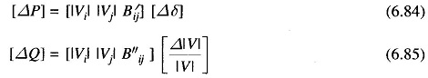](http://www.eeeguide.com/wp-content/uploads/2016/11/Decoupled-Load-Flow-Methods-5.jpg)

where B′ij, B′′ij are elements of [— B] matrix.

**COMPARE THE GAUSS SEIDEL AND NEWTON RAPHSON METHODS OF LOAD FLOW STUDY**

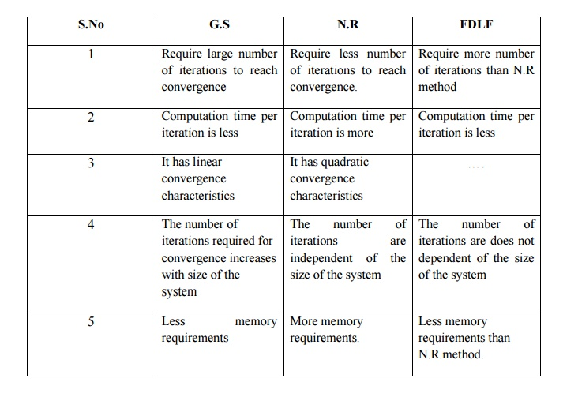

6.8 comparisons of load flow methods

in this section, GS and NR methods are compared when both use BIJS as the network model. it is experienced that the GS method works well when programmed using rectangular coordinates, whereas NR requires more memory when rectangular coordinates are used. Hence, polar coordinates are preferred for the NR method. I   
The GS method requires the *fewest* number of arithmetic operations to   
complete an iteration. This is because of the sparsity of the network matrix and the simplicity of the solution techniques. Consequently, this method requires less time per iteration. With the NR method, the elements of the Jacobian are to be computed in each iteration, so the time is considerably longer. For typical large systems, the time per iteration in the NR method is roughly equivalent to 7 times that of the GS method [20]. The time per iteration in both these methods increases almost directly as the number of buses of the network.   
The rate of convergence of the GS method is slow (linear Convergence characteristic), requiring a considerably greater number of iterations to obtain a solution than the NR method which has quadratic convergence characteristics and is the best among all methods from the standpoint of convergence. In addition, the number of iterations for the GS method increases directly as the number of buses of the network, whereas the number of iterations for the NR method remains practically constant, independent of system size. The NR method needs 3 to *5* iterations to reach an acceptable solution for a large system. In the GS method and other methods, convergence is affected by the choice of slack bus and the presence of series capacitor, but the sensitivity of the NR method is minimal to these factors which cause poor convergence.

Therefore, for large systems the NR method is faster, more accurate and more reliable than the GS method or any other known method. In fact, it works for any size and kind of problem and is able to solve a wider variety of ill- conditioned problems [23]. Its programming logic is considerably more complex and it has the disadvantage of requiring a large computer memory even when a compact storage scheme is used for the Jacobian and admittance matrices. In fact, it can be made even faster by adopting the scheme of optimally renumbered buses. The method is probably best suited for optimal load flow studies (Chapter 7) because of its high accuracy which is restricted only by round-off errors.   
The *chief* advantage of the GS method is the ease of programming and most efficient utilization of core memory. It is, however, restricted in use of small size system because of its doubtful Convergence and longer time needed for solution of large power networks.   
Thus the NR method is decidedly more suitable than the GS method for all but very small systems.